Prelab:
Write the code for sections 1 and 2. You will test the code in lab.

Overview, what is this lab about?
In the last lab, you created performed bit banging operations to clock serial data into a shift register and light one segment of an LED array. The parallel outputs of the shift register were connected to LED lights.
In this lab you will continue to work with the serial to parallel shift register, developing function calls to simplify your code and perform some new functions.

First you will start with a piece of code that drives a speaker with a tone. Then you will go through the following steps:
Pin Detection: You will create code to automatically detect which pin that speaker is connected to and reconfigure the microcontroller pins to drive the speaker, regardless of where it is connected.
You will modify the code so that it only prints a message when the speaker pin is changed.
You will create a counter to count switch presses. One switch SW1 will count up, another switch SW2 will count down. You will see observe that the switch counter sometimes jumps erratically due to switch bounce.
You will create code that debounces switch inputs using a simple delay so that the switched behave as expected.
You will create code to light a bargraph that shows the count of switch presses (numTimesPressed).

You will also learn how to use a digital pin to measure execution time of code.

You’ll be building your skills in
- reading a printed circuit board schematic to identify which microcontroller pins need to be configured as inputs or outputs
- using on-line references to learn about code library functions you can leverage. e.g. Tone library
- dynamically sensing and adapting to I/O configuration.
- Using functions to simplify the logic flow of code.
- Measuring execution time using hardware test flags with an oscilloscope.

How to Succeed With This Lab:
Read the overview. Refer back to the previous lab handout for sample code. Utilize the Arduino.cc website for reference information on Arduino pin definitions and language. Read the schematic for the microcontroller board.
The number one problem students face doing this lab:
Determining power up conditions.
SECTION 1 – Completing Pin Map and Encapsulating I/O Setup.
Procedure:
- Unzip and extract the ‘Lab_4_start’ code from myCourses. With the CPET-202 board on your Arduino, set the speak jumper J7 to select SPK1, load the code, open the console window and push SW1. You should hear a tone and see a connectivity announcement scroll by. You can turn the tone off by closing and reopening the console, which resets the uC, or you can press the reset button on the microcontroller.
- Review the board schematic. Starting with last week’s configuration data, complete the mapping of microcontroller pins to externally connected elements e.g. switch 2.
SW_2_PIN
SPKR2_PIN
- Configure the pins as input pullup. Note that the speaker is driven from a switch block that allows the user to select drive from SPKA (jumper pins 1, 2) or from SPKB (pins 2, 3) or none (pins 3, 4).
In the function configureBoardPins(), set SW2 to be an input pullup and set SPRK2 as an input pullup.
- Obtain a signoff from the lab instructor

SECTION 2 – Bare Bones Speaker Drive
Procedure:
- Change the code to turn the tone off when SW1 is released (see Arduino reference for tone() function).
- Change the code to announce the speaker drive connection only once per beep. Look at the serial monitor. It should not be spitting out messages continuously.
- Verify that the speaker is not driven with the jumper in the second position.
- Demonstrate your working code to your instructor for a sign off.

SECTION 3 – Automatic Speaker Drive Identification
Procedure:
- Populate the getActiveBeepPin() function per the included pseudo code in the comments of Lab 4_starter. Verify that the speaker works in either jumper location and that the console announcement properly reflects the jumper status when SW1 is pressed.
- Demonstrate your working code to your instructor for a sign off.

SECTION 4 – Speaker ID Spam Reduction
Procedure:
- Inside the procedure displayBeepPin() add a variable lastbeepPin and use it to enable the SW1 down stroke console announcement only if the speaker connection has changed since the last beep request.
- Try declaring the variable lastbeepPin as a static int versus an int.

- Demonstrate your working code to your instructor for a sign off and explain why the static int matters.

SECTION 5 – Switch Count Up/Down
Procedure:
- Inside the procedure countSwitchPresses(), create a counter called numTimesPressed to count switch presses. Pressing switch SW1 will count up, pressing switch SW2 will count down.
- Serial print the value of numTimesPressed only if the value has changed (up or down). Add code to do this inside of countSwitchPresses(). You may observe that the switch counter sometimes jumps erratically due to switch bounce, particularly when you slowly press or slowly release the switch.
- Demonstrate your working code to your instructor for a sign off showing Serial Monitor with numTimesPressed.

SECTION 6 – Bar Graph of numTimesPressed
Procedure:
- Now that you have a count of the number of times the switch has been pressed, you will create a bargraph of that count. If the count is five, all five segments will be lit up. If the count is three, three segments will be lit up. Instead of clocking in zeros behind a lit LED, you will clock in more ones behind the lit LED.
- You will need to fill in the code in several functions. First, fill in the code for pulseClk() by following the instructions in the comments in the function in Lab4_starter. Then fill in the code for clearShiftRegisterToZero() and then lightUpBarGraph().
- Demonstrate your working code to your instructor for a sign off showing the bar graph.

SECTION 7 – Measuring Code Execution Time
In future labs, it will be important to know how long it takes for your code to execute. There are two ways to do this. First, the microcontroller has an internal clock that can be used to measure the time from when a section of code starts to when it end. For the Arduino, the function is called micros(). The function returns long datatype value that is the microseconds since the last reboot. You can use this to calculate the elapsed time for a function to execute.
The second method is to set a digital pin HIGH at the start of the code and then set it LOW when the code finished executing. You will try both of these methods. Use the sample code below to get started.
…
//***********************************************************************************
void loop()
{
startMicroseconds=micros(); // to measure execution time
digitalWrite(QTR2_PIN,HIGH); // connect oscilloscope probe to this pin.

updateSwitchStates(); // function call to update state of switches (pressed/not pressed)
countSwitchPresses(); // increment or decrement counter of switch presses
//countSwitchPressesUsingStateMachine(); // avoids any risk of switch bounce
lightUpBarGraph(numTimesPressed); // light all LEDs from bottom up to numTimesPressed level

digitalWrite(QTR2_PIN,LOW);
elapsedMicroseconds=micros()-startMicroseconds; // to measure execution time
Serial.print("loop execution time was ");
Serial.print(elapsedMicroseconds);
Serial.println(" microseconds.");
…

Procedure:
- Modify the code to add the bolded lines from the text box above.
- Record the value printed in the serial monitor.
- Connect an oscilloscope probe to QTR2_PIN and record the execution time from the scope.
- Change the delay(10); in the main loop to be delay(1); Press the switches to light up the bar graph and note how some of the LED’s are dimly lit. This is because of the relatively slow speed at which the Shift Register values are being cleared using the digital write function. In future labs, you will speed up the execution of the code and this will make the off LEDs appear fully off.
- Show your instructor the scope results and dim LEDs for your sign off.
Write Up:
There is no write up for this lab, just get the items on the cover sheet (next page) signed off by your lab instructor and submit just the cover sheet in class.

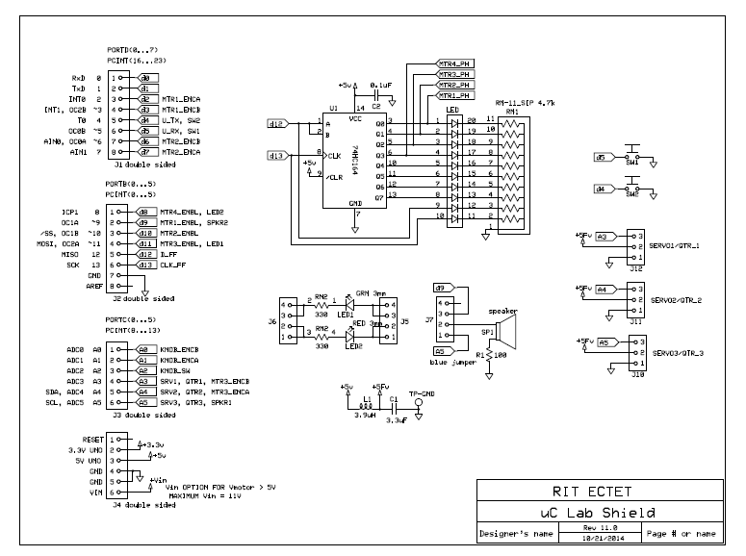
Date: ______________________

Names: ______________________

Section: ______________________

LABORATORY CHECK OFFS
Section 1  Code for configuring pins as inputs and outputs SW2, SPKR2  Section 2  Bare bones speaker drive, speaker turns off when switch 1 released.  Section 3  Automatic speaker drive identification  Section 4  Speaker ID spam reduction and explain why it must be a static int  Section 5  Serial Monitor with numTimesPressed counting up and down  Section 6  Bar Graph of numTimesPressed  Section 7  Execution Time Measurement value using micros() = ___________  Execution Time Measurement value using oscope = ___________  LED’s are dimly lit when delay(1) is used. | ____  ____  ____  ____  ____  ____  ____
Points | ____

